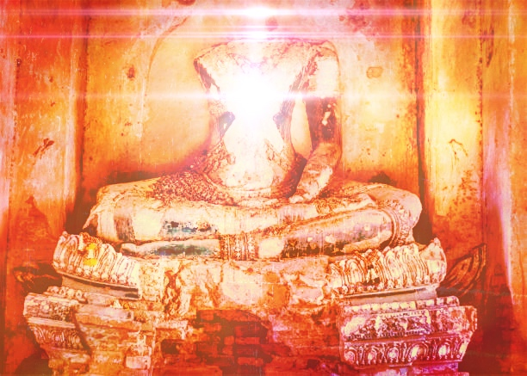

**Infinite Armed Tara Dakini:**

**Awakening Activity Through Boundless Non-referential Universal Compassion**

Instantly, I appear in whatever pose I am naturally in as two armed Avalokitesvara. I am in sambhogakaya, peaceful garments with the luster and qualities of incredible jewels. My heart is a lotus with the six syllable mantra and red Hrih in the middle. The mantra wheel blazes like a raging solar surface as I am overcome with recollection of the extensive continuous suffering endured by sentient beings!

To be a sentient being is to be in the clutches of the Lord of Death, Yama Dharmaraja, who turns the wheel of the twelve-links of dependent origination and who, through our own ignorance, attachment, and aversion, flings beings into any one of the thirty six abodes of the six classes of beings. Beginningless-endless time is none other than Death itself.

Well, upon becoming a sentient being, isn’t it enough that the entirety of existence isn’t suffering, but that we experience various pleasures and happinesses? No. These pleasures and happinesses are temporary because of the nature of being (which cannot be directly understood outside of extrasensory yogic direct perception) and the nature of death and becoming. Because we cycle endlessly, there is no pleasure in pleasures. If we know the truth of the nature of being through direct yogic extrasensory perception, then there is no such thing as pleasures and pains of this life - instead there is what is known as “Great Bliss.”

To establish all beings in Great Bliss, to transfer them from the whirlpool of ignorance to the crystal palace of supremely peaceful wisdom that appears from the outside either as a peaceful oasis or a raging charnel ground requires immense power and wisdom.

To sacrifice oneself wholly and completely through meditative gnosis for the attainment of the immense power and wisdom to benefit sentient beings is the path. To embark on that path is to cry the tears of Avalokiteshvara, whereupon the Awakened One, Tara, the Swift Savioress, emanates enlightened activity and long-life capacities. That means you will have to generate compassion that makes your head explode.

So you should understand this practice as the contemplation that gives way to the defeat of Avalokiteshvara. That is, you should contemplate trying to benefit sentient beings as you are, until you are so thoroughly convinced of your own uselessness that you give up and your head explodes, which is when your bodhichitta heart will cry out.

If you correctly contemplate the nature of suffering and sentient beings, you will correctly realize the need for an Awakened One. At this exact moment, one of Tara’s infinite arms will reach out to you along with the dakini message “Don’t be afraid; Just hold my hand!”

Then, you will become a Great Being, a Heroic Being, a Child of Noble Family, a Child of the Awakened Ones and Great Heroes of the Ten Directions and Three Times, and so on. You will be known as Jinaputra and when Jinaputra comes to realization, Jinaputra will be known as Vidyavajra. When Vidyavajra comes to realization, Vidyavajra will be known by myriad names such as Very Joyful, Stainless, and so on up to Cloud of Dharma; and upon realization, Cloud of Dharma will be known by myriad names up to and including Awakened One and Illuminator and Mother of All the Awakened Ones. This is how it is. This is the intricate fractalization of the union-mandala of the sentient being who is the child, Great Bliss, the Bodhisattva Aspirant Vidyavajra, the Bodhisattva Very Joyful, Stainless, and so on up to Cloud of Dharma, and the Awakened One, Illuminator, Buddha, Supreme Wheel-Turning Nirmanakaya, Teacher, Mother of All the Awakened Ones and so on reflected in their phenomena by their own bodhichitta.

When you understand this practice you will be held by the mother of all the Awakened Ones, Tara, and she will raise you. This is the true meaning of one whose realization grants them the name Jinaputra. Understand this, Heart-Child, and you will come into the experiential initiation and empowerment of the Infinite Armed Savioress, Tara the Swift Liberator. Then, you will meditate like this:

Instantly, all infinite phenomena are adorned with the arms of the savioress, Tara, the Swift Liberator and Dakini Queen-Consort.

Remaining like this, the five outer elements I claim as myself dissolve into wisdom light, breaking open the cocoon of Mara’s trickery and instantly bringing to fruition the swiftly liberating, deep, perfect wisdom of Tara as my continuum becomes inseparable from the dakini. This is the Primordially Awakened King of the Lineage of Great Bliss in Union with the Infinitely Beautiful Dakini Queen-Consort.

Remaining like this, I experience Great Bliss and the essence of death is overcome as the blessings of Wisdom Mind condense into a single drop of long-life immortal amrita that emanates directly into my entire continuum and dissolves (repeat as many times as you like).

Suddenly, I realize that as a concomitant result, enlightened activity prevails as Tara’s infinite arms adorn all infinite phenomena without any effort, and I remain in the state of Tara’s intent, benefitting beings spontaneously as peaceful and wrathful displays. This is the Union/dance.

Sarvamangalam!

*Written by the new Acharya - 9/14/22.*